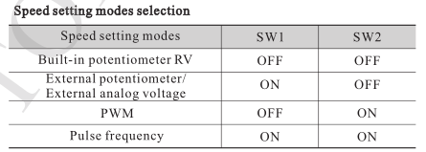

Pairs of poles | SW5 | SW6
2 | ON | OFF
4 | OFF | ON
5 | ON | ON
Default setting | OFF | OFF

Open loop: SW7=ON
Closed loop: SW7=OFF

Closed loop mode(useless when SW7=ON):

SW8=ON closed loop for current
SW8=OFF closed loop for speed and current

